Directory

1. Deployment 2

1.1 Environment 2

1.2 Export The War 2

1.3 Launch Own Server 4

1.4 Install Tomcat 5

1.5 Upload and Copy the War under the Webapps directory 5

1.6 Reboot Tomcat 6

1.7 Check 6

2. Test in behave 7

2.1 Install Python 7

2.2 Install behave 7

2.3 BDD module 8

2.4 The File structure of the Test 8

2.5 Use behave to test 9

2.6 Use Linux Shell Command Curl to test 10

3. LoadRunner for testing Complex Projects 11

3.1 Install LoadRunner Software 11

3.2 Use LoadRunner’s Virtual User Generator 11

3.3 Use LoadRunner’s Controller 17

3.4 Use LoadRunner’s Analysis 21

# 1. Deployment

## 1.1 Environment

Server: AWS EC2

OS: Ubuntu

IDE: Eclipse

Software: Tomcat7

## 1.2 Export The War

After coding in the local computer’s eclipse, then export the project as war.

Right click the project, and choose “Export”

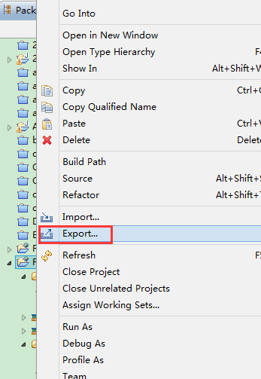

Choose the export type（war）

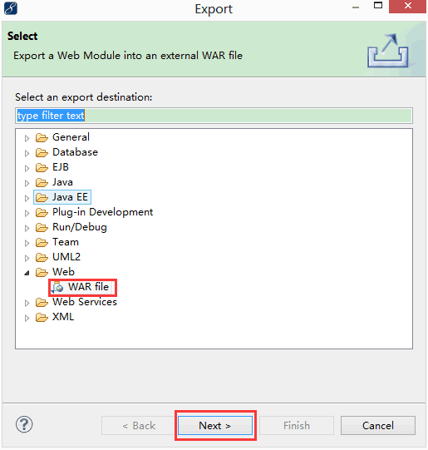

Choose the place for the war.

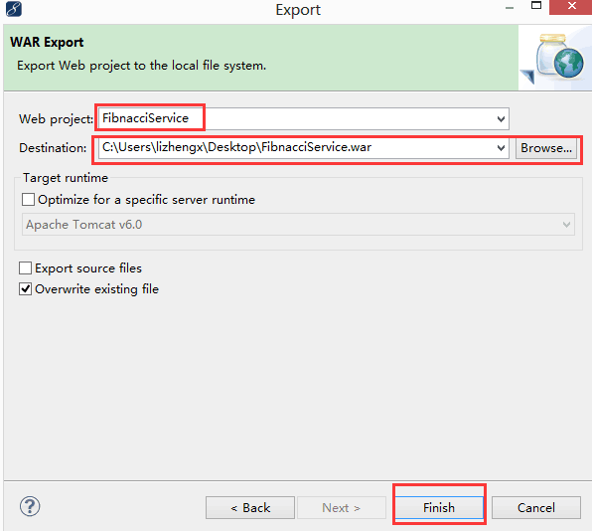

## 1.3 Launch Own Server

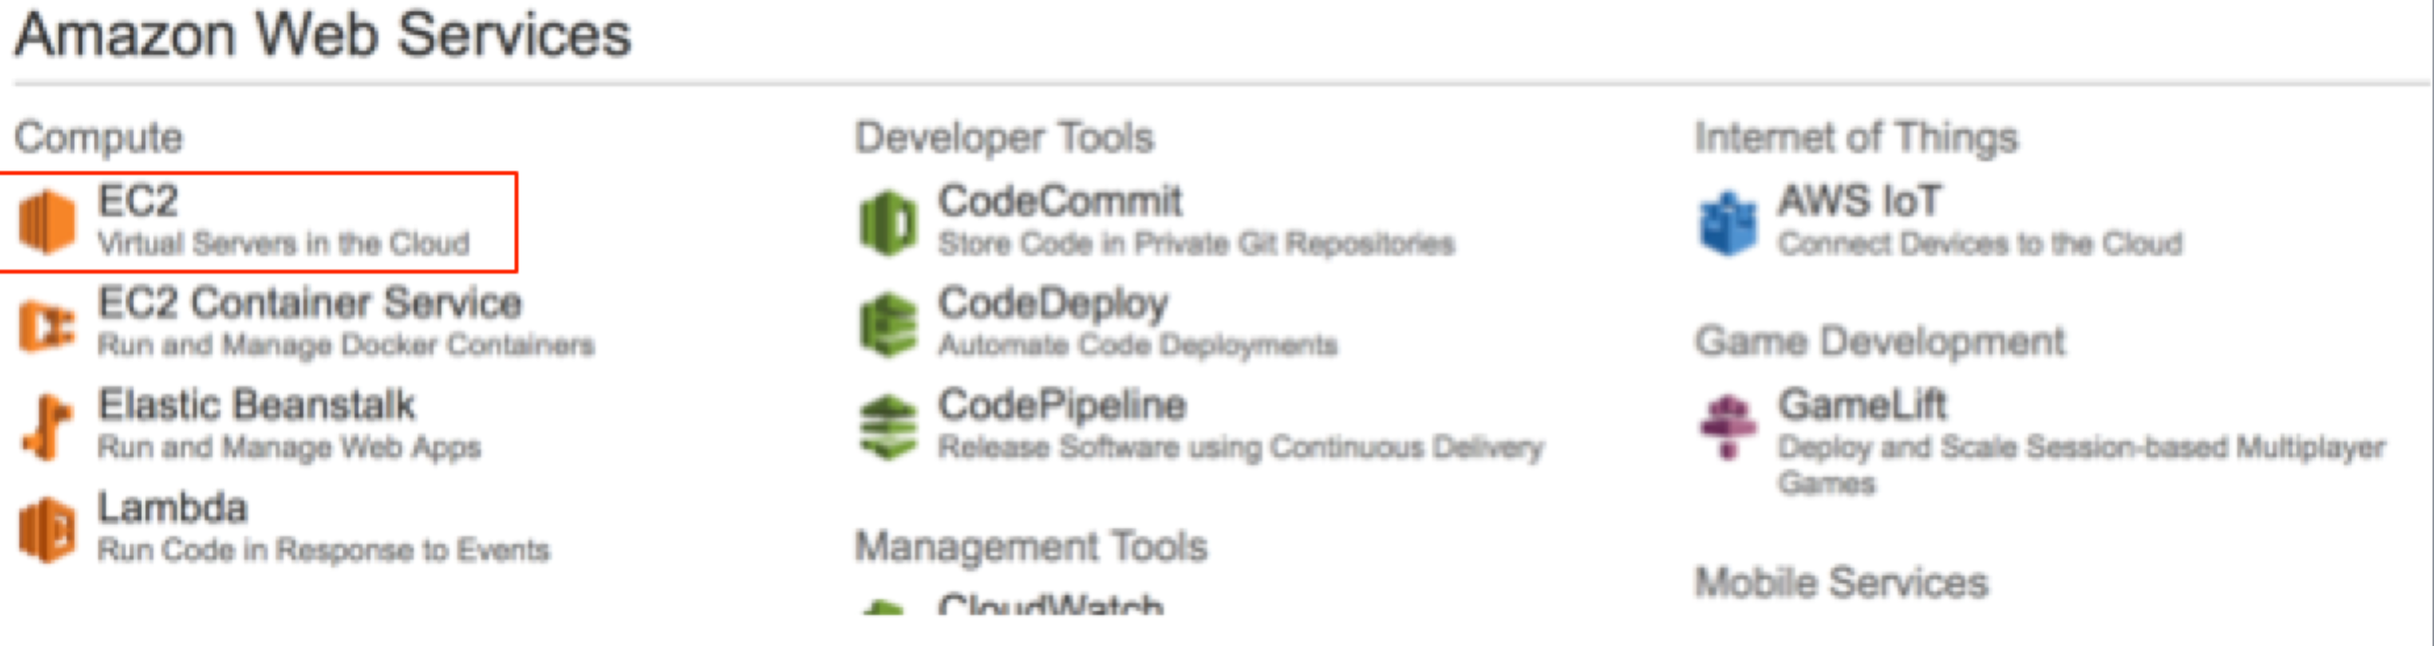

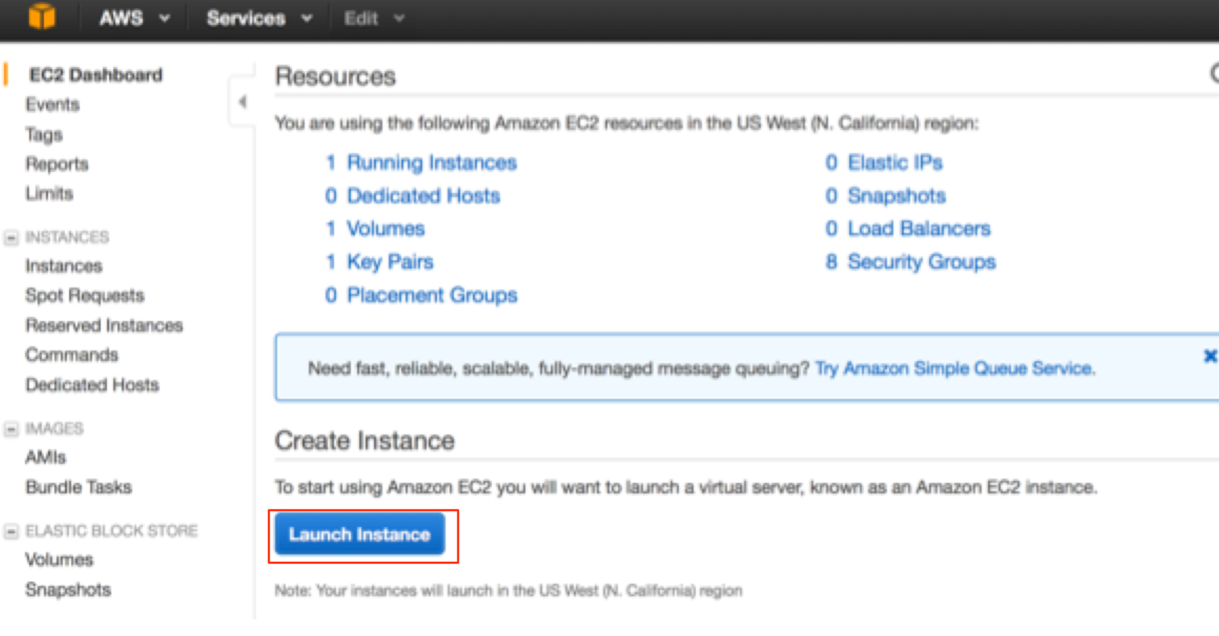

After launching the server, change the Network Security groups for permission of different protocols

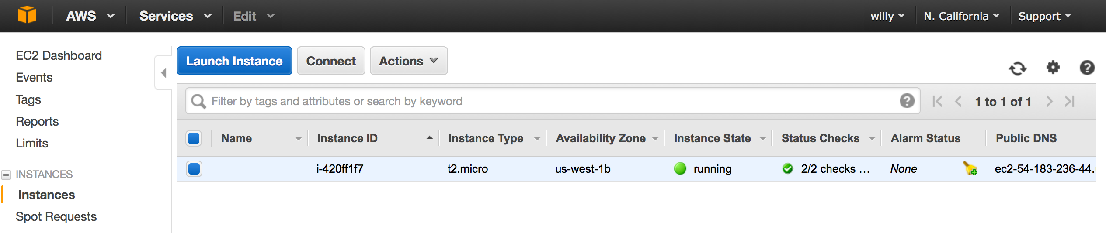

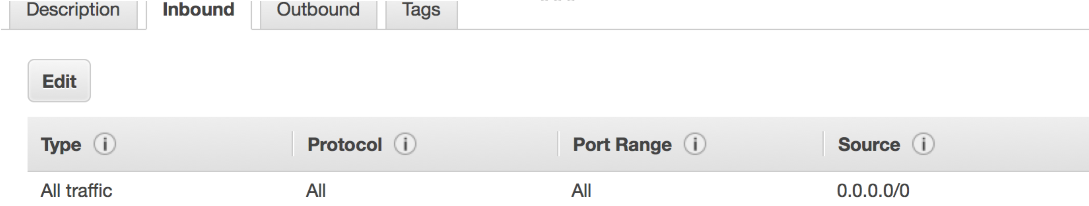

Access in the EC2 by using ssh in command line:

ssh -i cdv.pem ubuntu@ec2-54-183-236-44.us-west-1.compute.amazonaws.com

## 1.4 Install Tomcat

Use command line：

apt-get install tomcat7

## 1.5 Upload and Copy the War under the Webapps directory

After installation, webapps directory would be under var/lib/tomcat7. Put the FibnacciSerivce.war under webapps directory.

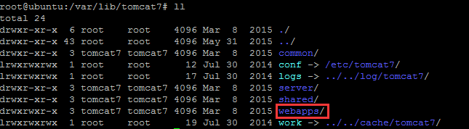

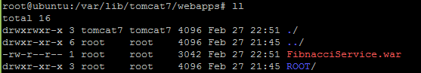

## 1.6 Reboot Tomcat

Command line:

Boot：service tomcat7 start

Stop：service tomcat7 stop

Reboot：service tomcat7 restart

After rebooting tomcat7, there would be a FibnacciService directory under webapps directory

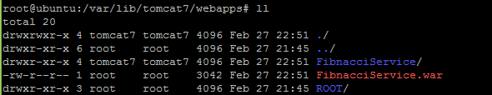

## 1.7 Check

To check whether the deployment is successive or not: Use browser and type in:

<http://54.183.236.44:8080/FibnacciService/>

54.183.236.44 is the server IP address.

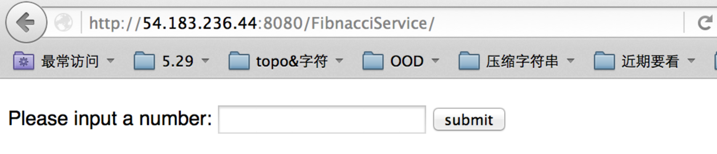

# 2. Test in behave

In this part, python’s behave framework is used for functional testing and simple performance testing.

## 2.1 Install Python

Command line:

apt-get install python3.4-dev

## 2.2 Install behave

Command line:

apt-get install python3-pip

python -m pip install behave

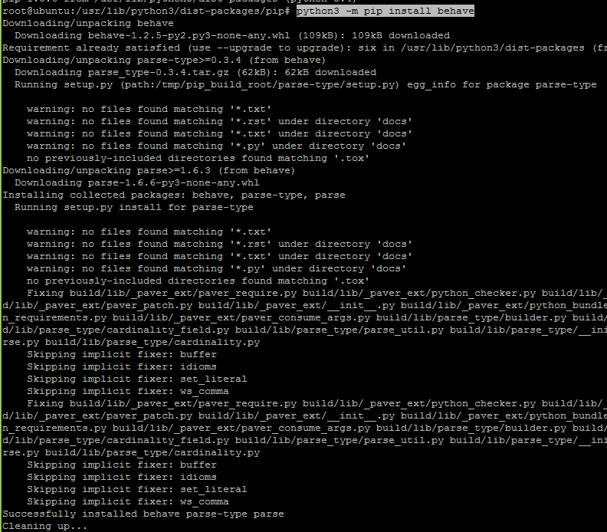

## 2.3 BDD module

BDD: Behavior Driven Development, which can allow programers to use natural language to describe the functions and scenarios of the system.

## 2.4 The File structure of the Test

test

|_fib.feature ---------------------> BDD module description file

|_steps

|_fib.py ---------------------> Test script

In fib.feature, there are some test scenarios with two parameters: <input> and <output>, as well as some test case:

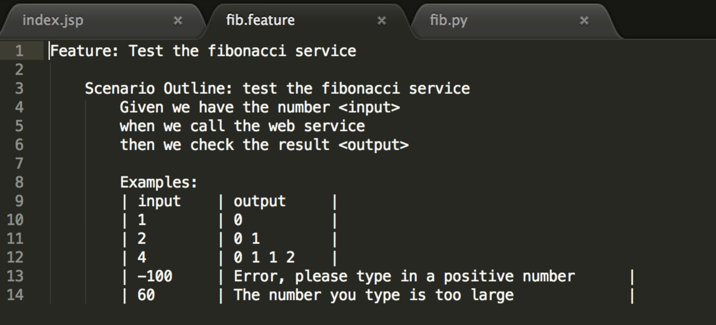

In fib.py, there would some backend code, which is a must because the test needs to send HTTP request. The code in this file imports a httpurl module to send http request.

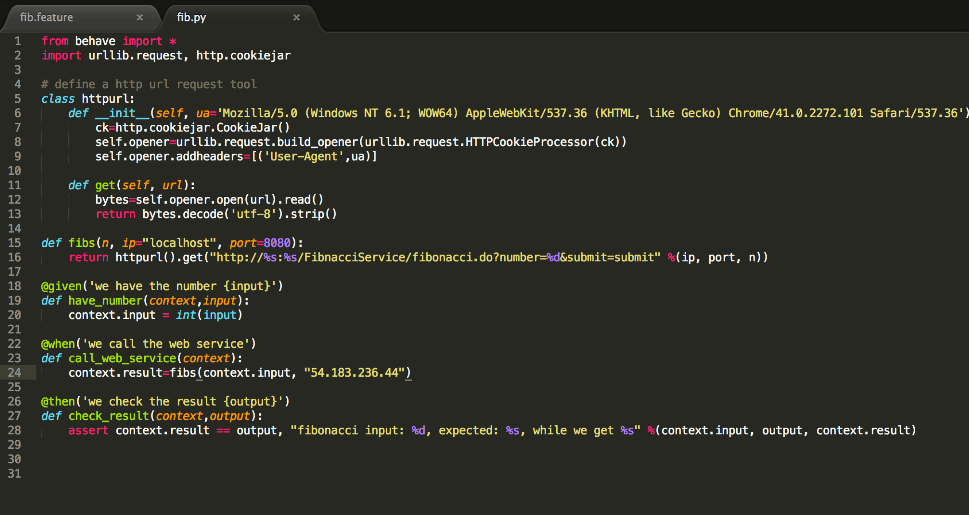

## 2.5 Use behave to test

Execute the behave command under test directory. The result is :

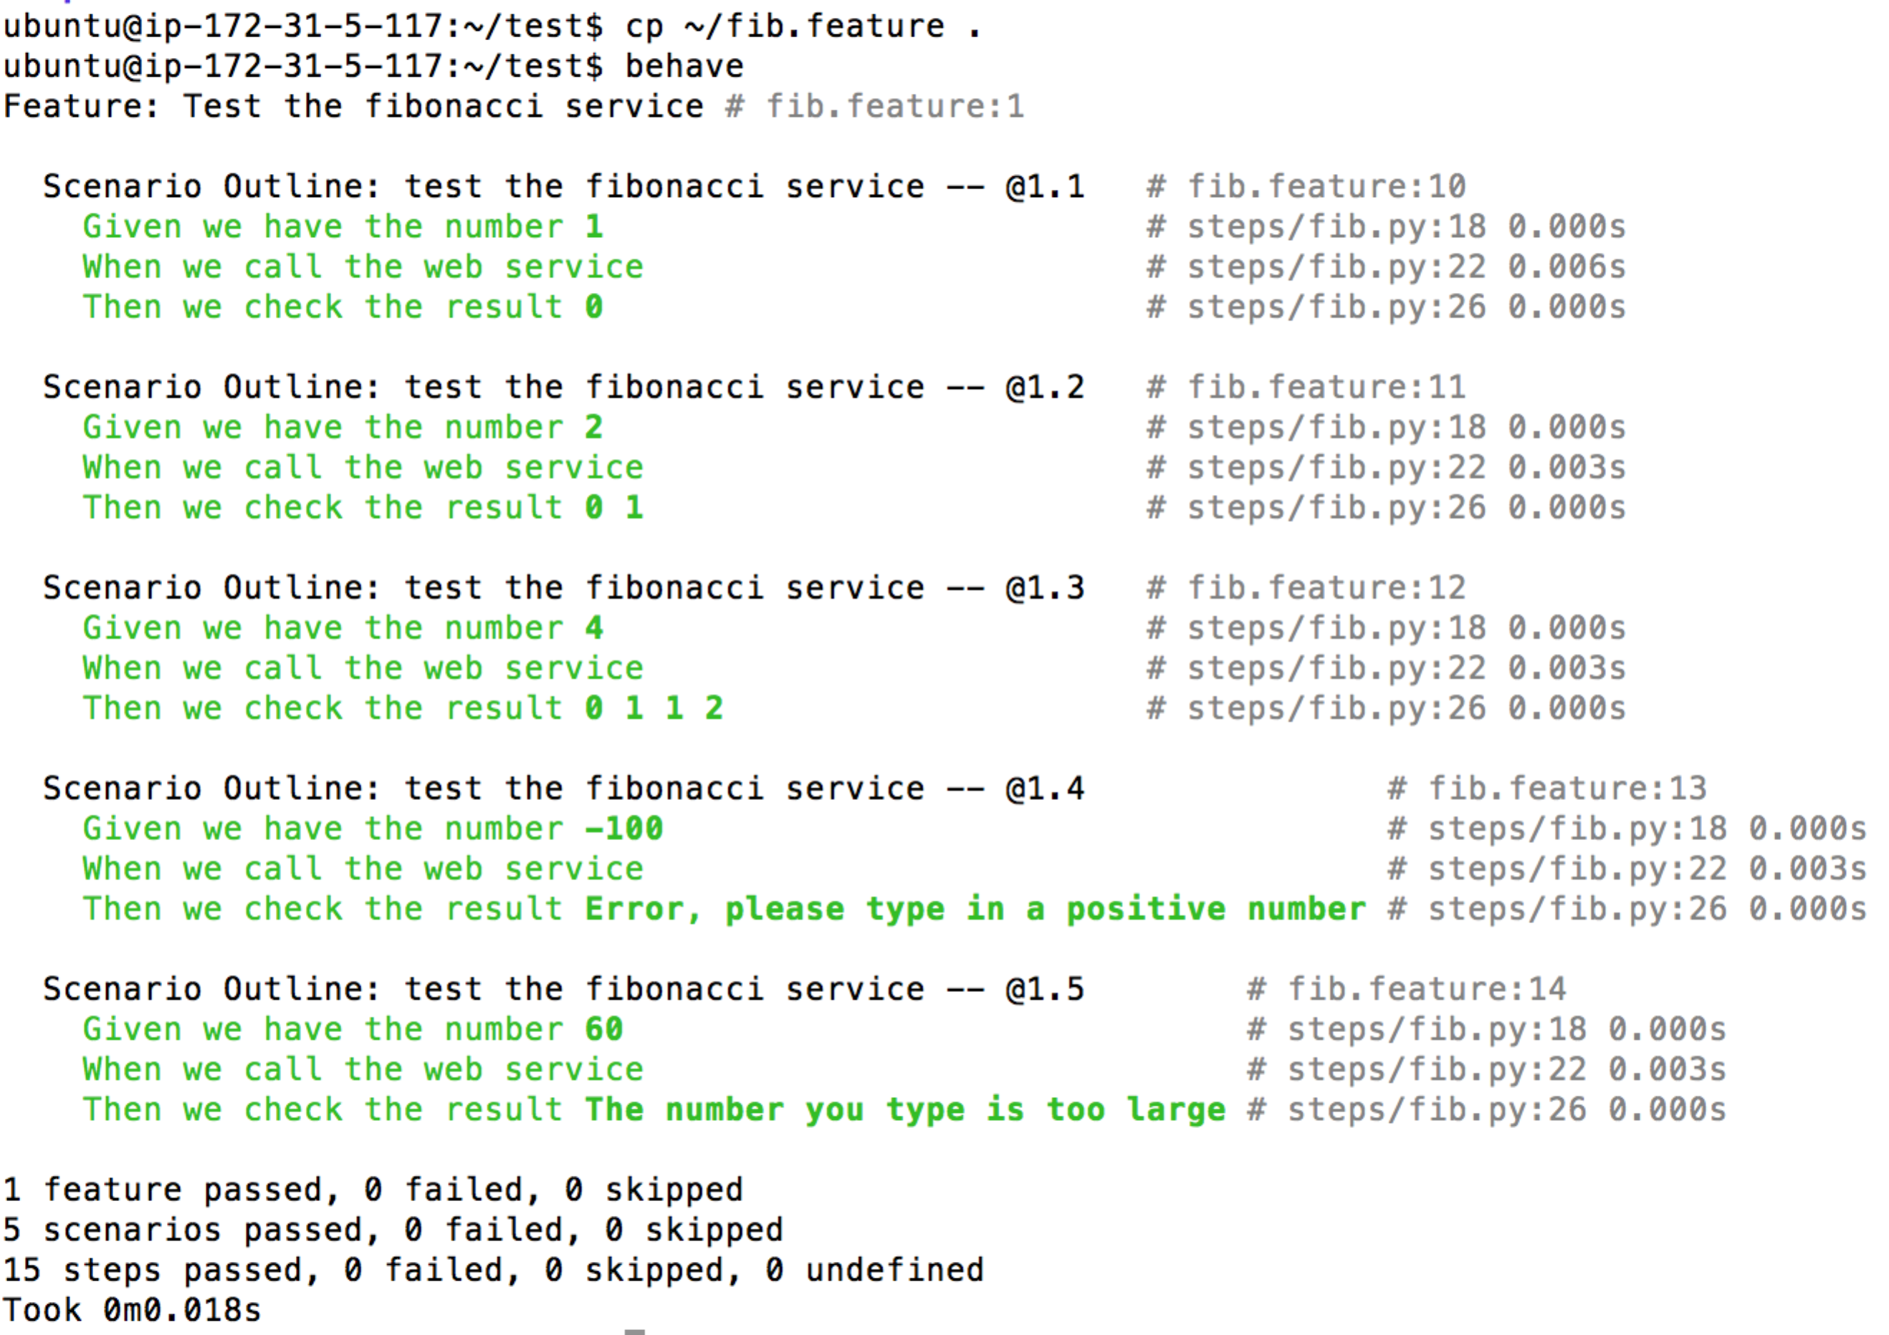

## 2.6 Use Linux Shell Command Curl to test

Command Line:

time curl "http:// 54.183.236.44:8080/FibnacciService/fibonacci.do?number=40&submit=submit"

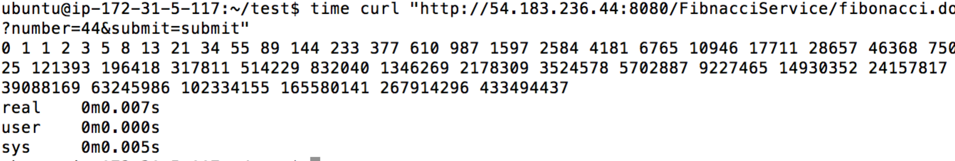

The response time is displayed in the screen.

# 3. LoadRunner for testing Complex Projects

In order to insure that the complex projects, including web services, mobile apps, and online games, which would be put into production and be maintained for 5 years, can have a good and stable performance, performance testing and load testing are necessary.

LoadRunner is a well-known tool for performance testing and load testing. By using LoadRunner, programmers can get many project’s index like response time, throughput, Hits per second, and concurrent users.

This following part would give the example of using LoadRunner to do the testing on FibnacciService as well as some principles of testing on complicated projects.

## 3.1 Install LoadRunner Software

Download the software in HP webstie:

http://www8.hp.com/cn/zh/software-solutions/loadrunner-load-testing/index.html

## 3.2 Use LoadRunner’s Virtual User Generator

There are 3 major applications of LoadRunner: Virtual User Generator, Controller and Analysis. The first one is Virtual User Generator. Programmers can use Virtual User Generator to generator the testing script, in which users’ different operations or the group of operations are defined as transactions.

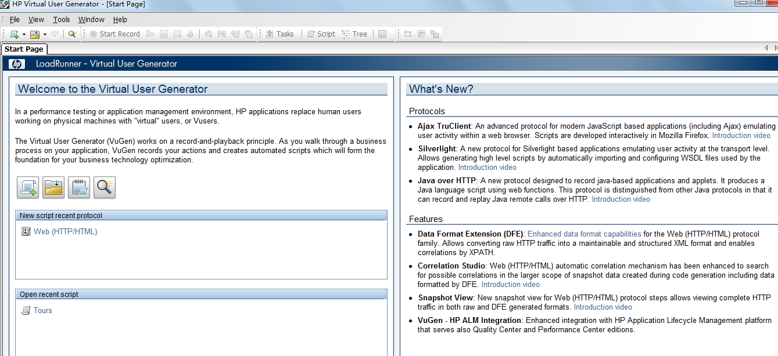

Create a new script

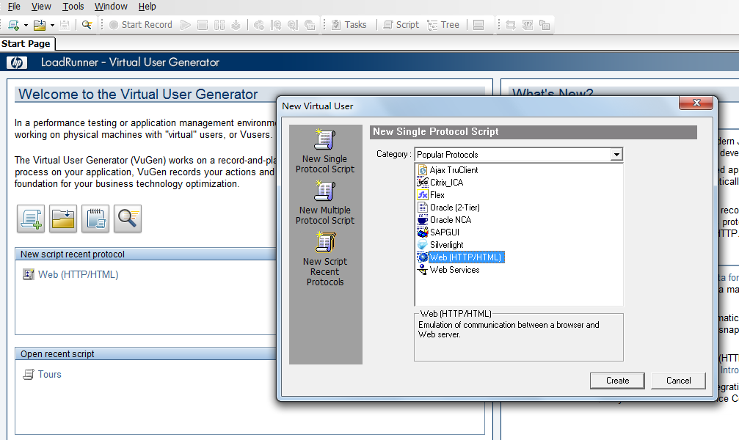

Record the actions to form the script

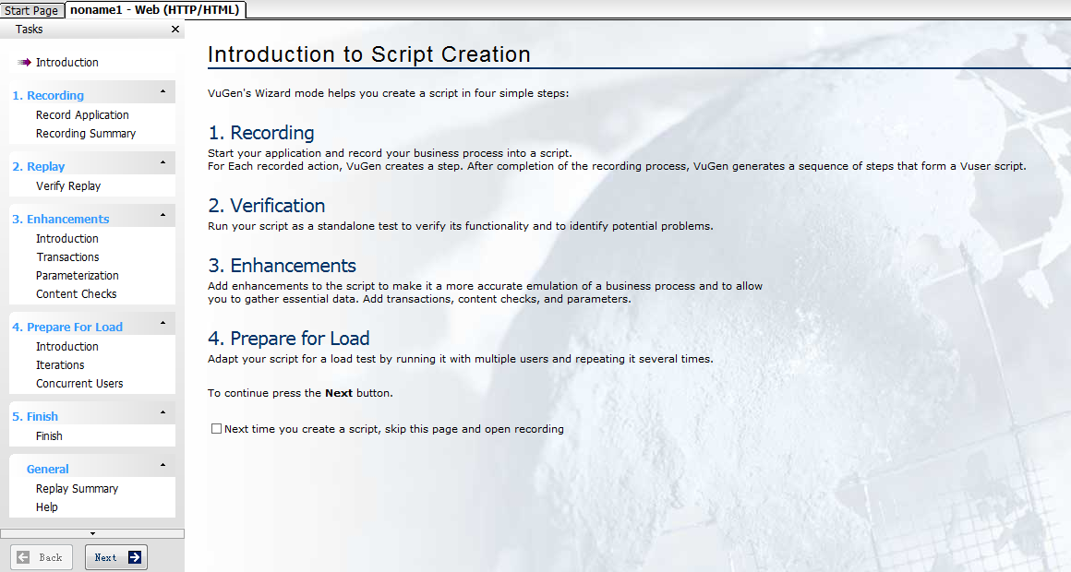

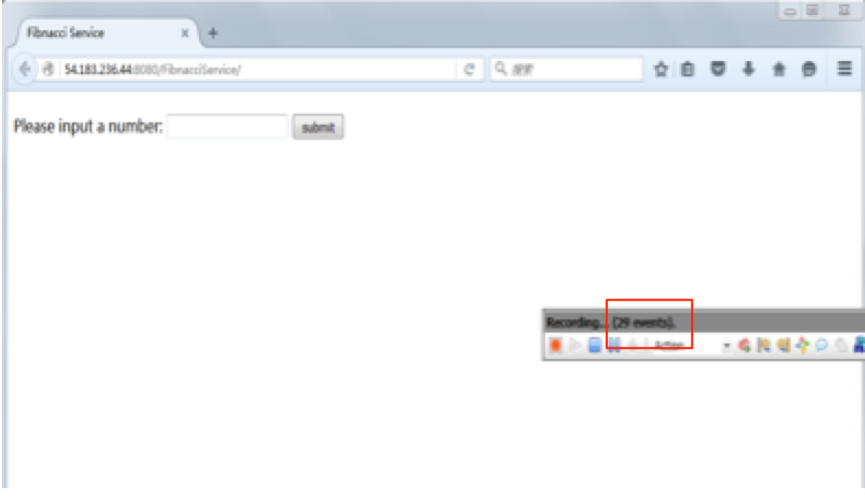

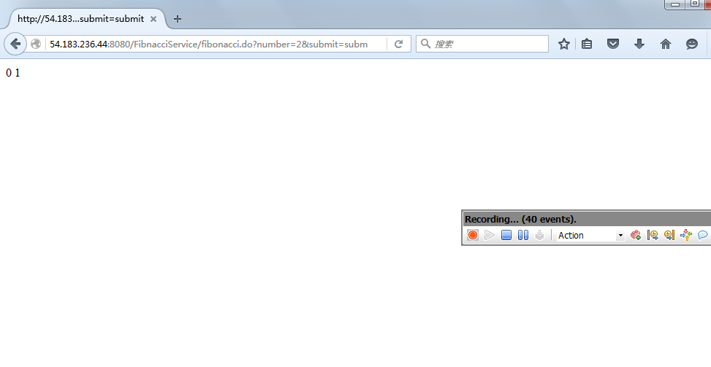

Verify the script.

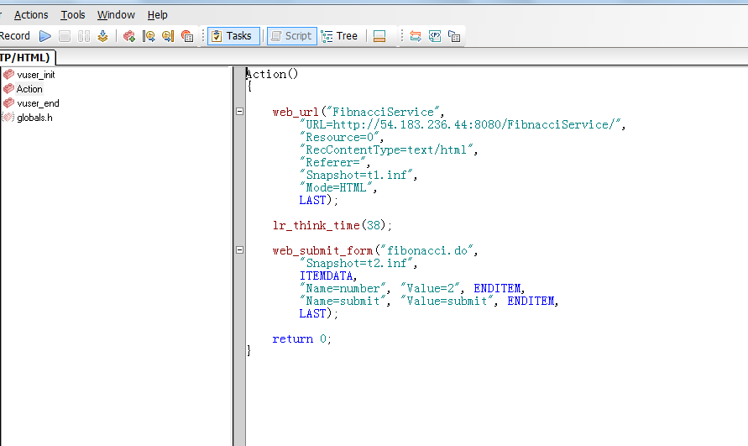

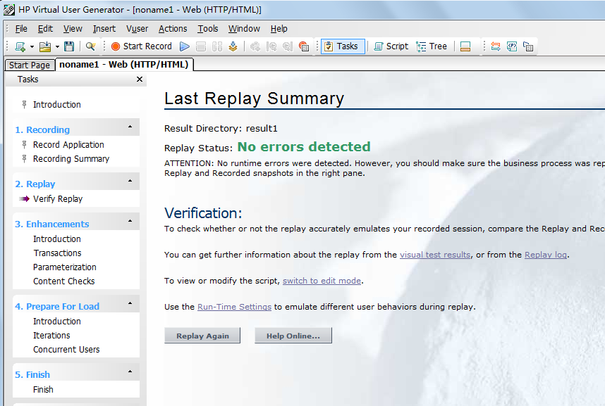

Define the transaction, in order to measure the specific operations. In complex projects, it’s important to define each transaction like login, search and book a ticket. In this project, the submission of a number for Fibnacci numbers is defined as a transaction.

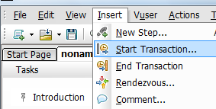

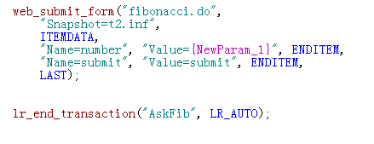

Parameterize the script. In order to simulate a real situation of different users using the system, programmers should parameterize the data which would be submitted to the system. Otherwise

all virtual users would submit the same request based on the script, which is not reasonable and would cause negative effect on the testing.

For this project, the data submitted to get Fibnacci numbers is parameterized.

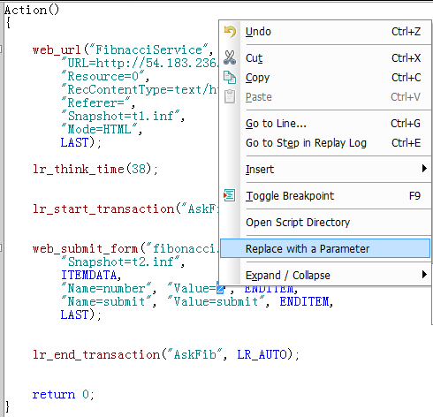



Error handling methods should also be added for complex projects’ testing. For complex projects, specific error handling methods are important. For example, when the testing is on, some small errors like missing logo pictures can be ignored, in order to focus on other major points and accelerate the creation and verification of the script. For this project, no error handling methods are implemented.

## 3.3 Use LoadRunner’s Controller

In order to test the load burden and maximum concurrent users number the system can handle, the simulation of real situations is a must. The loadRunner’s Controller is the tool to generate multiple users and their different operations.

Import the script which is created and verified from the Virtual User Generator

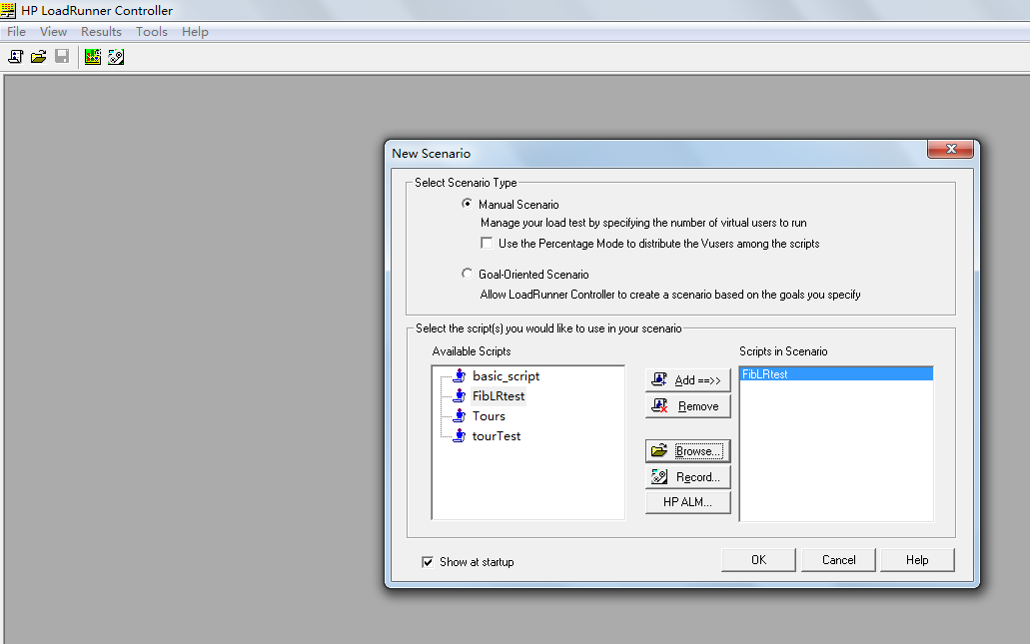

Set the scenario. For complex systems, a detailed and a possibly happening scenario must be created for the test. For this project, 24 virtual users are generated, and they are generated one by one in the interval of 1 second. (Due to my free trial, I could not launch more than 25 Vusers… But 24 Vusers can’t cause enough load on this project.)

To be noticed, it would consume 2M – 3M memory space to generate one virtual user. So for complex projects, it would be better to use one server as the manager, and use multiple servers as slaves to generate virtual users. For this project, the local server is used to generate virtual users.

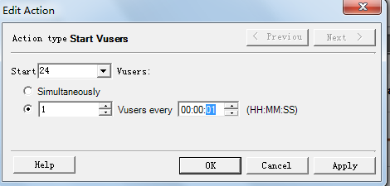

Set the duration to 2 minutes

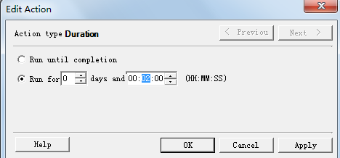

Prepare to run the controller’s test.

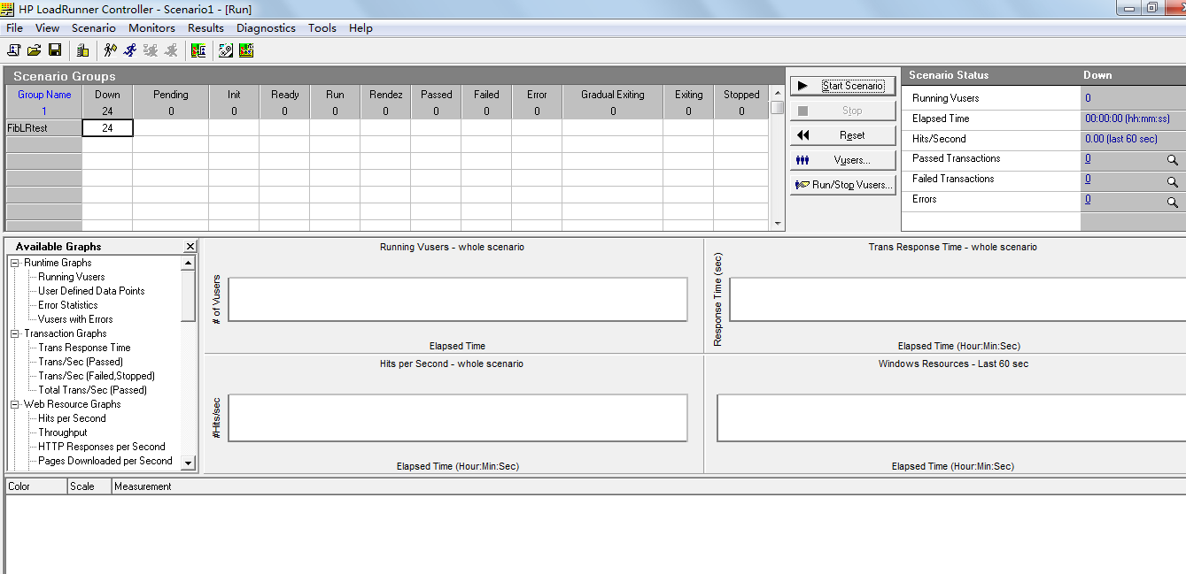

Running the test

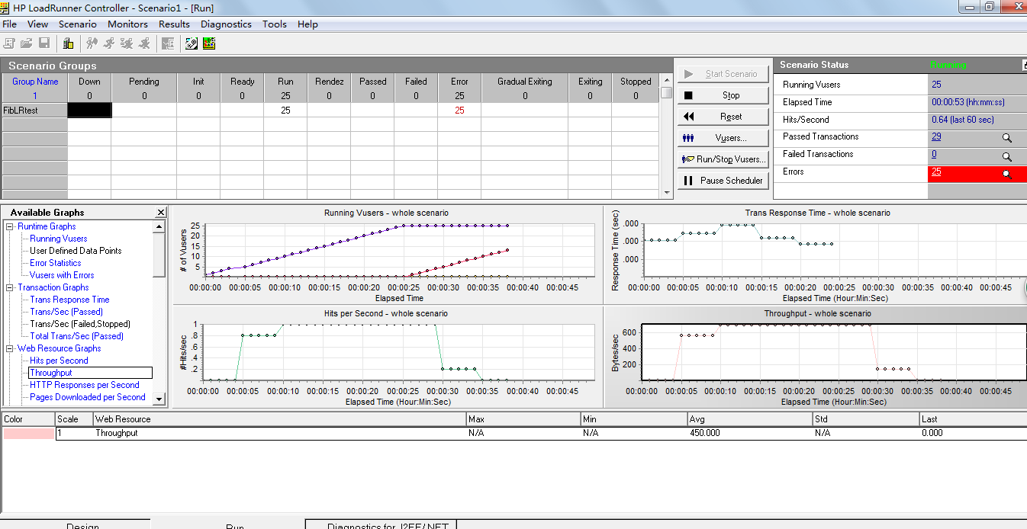

The result

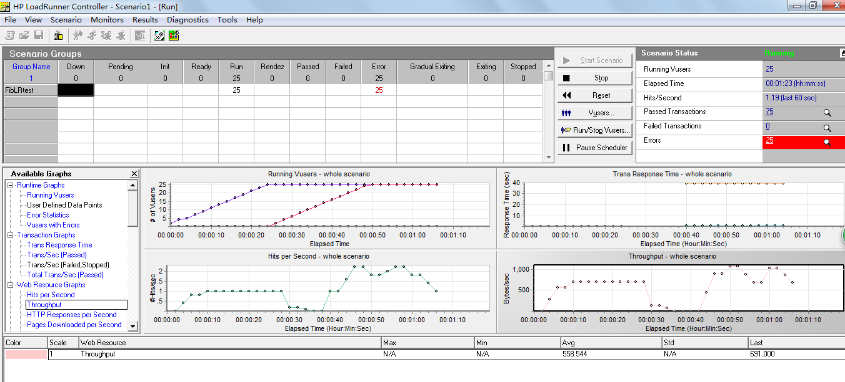

Set the Rendezvous. When virtual users are operating based on the script, the order of virtual users’ operations are different. Rendezvous is to set a mark in the script, so that the virtual users would stop at that point until other virtual users also reach the same point. Then the virtual users would operate simultaneously. This action would put great heavy on some specific transaction, and it’s effective to evaluate some specific functions of a complex project. In this project, no rendezvous is marked.

## 3.4 Use LoadRunner’s Analysis

LoadRunner’s Analysis is the tool to generate readable and effective graph based on the result of the controller’s test. (Due to the fact that the Analysis in my computer doesn’t work, I would only

display the sample graph of LR and list some principles and operations for complex projects in this part)

Analyze the graph for evaluating performance:

1. Average Transaction Response Time Graph

The trend of system performance’s variation during the test can be shown by this graph For example, if the response time goes up with the test time going, the system performance has the trend to degrade with time going. Each transaction’s average response time can also be shown.

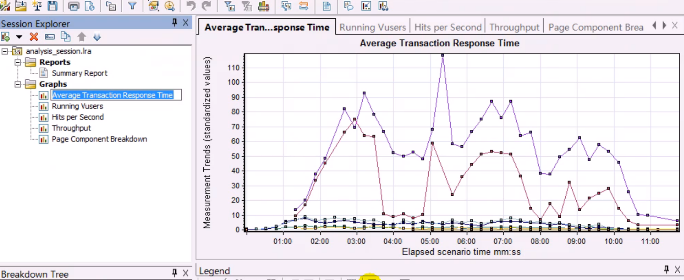

2. Vuser and Transaction Response Correlated Graph

It can be used to analyze how the transaction response time change with the numbers of virtual users.

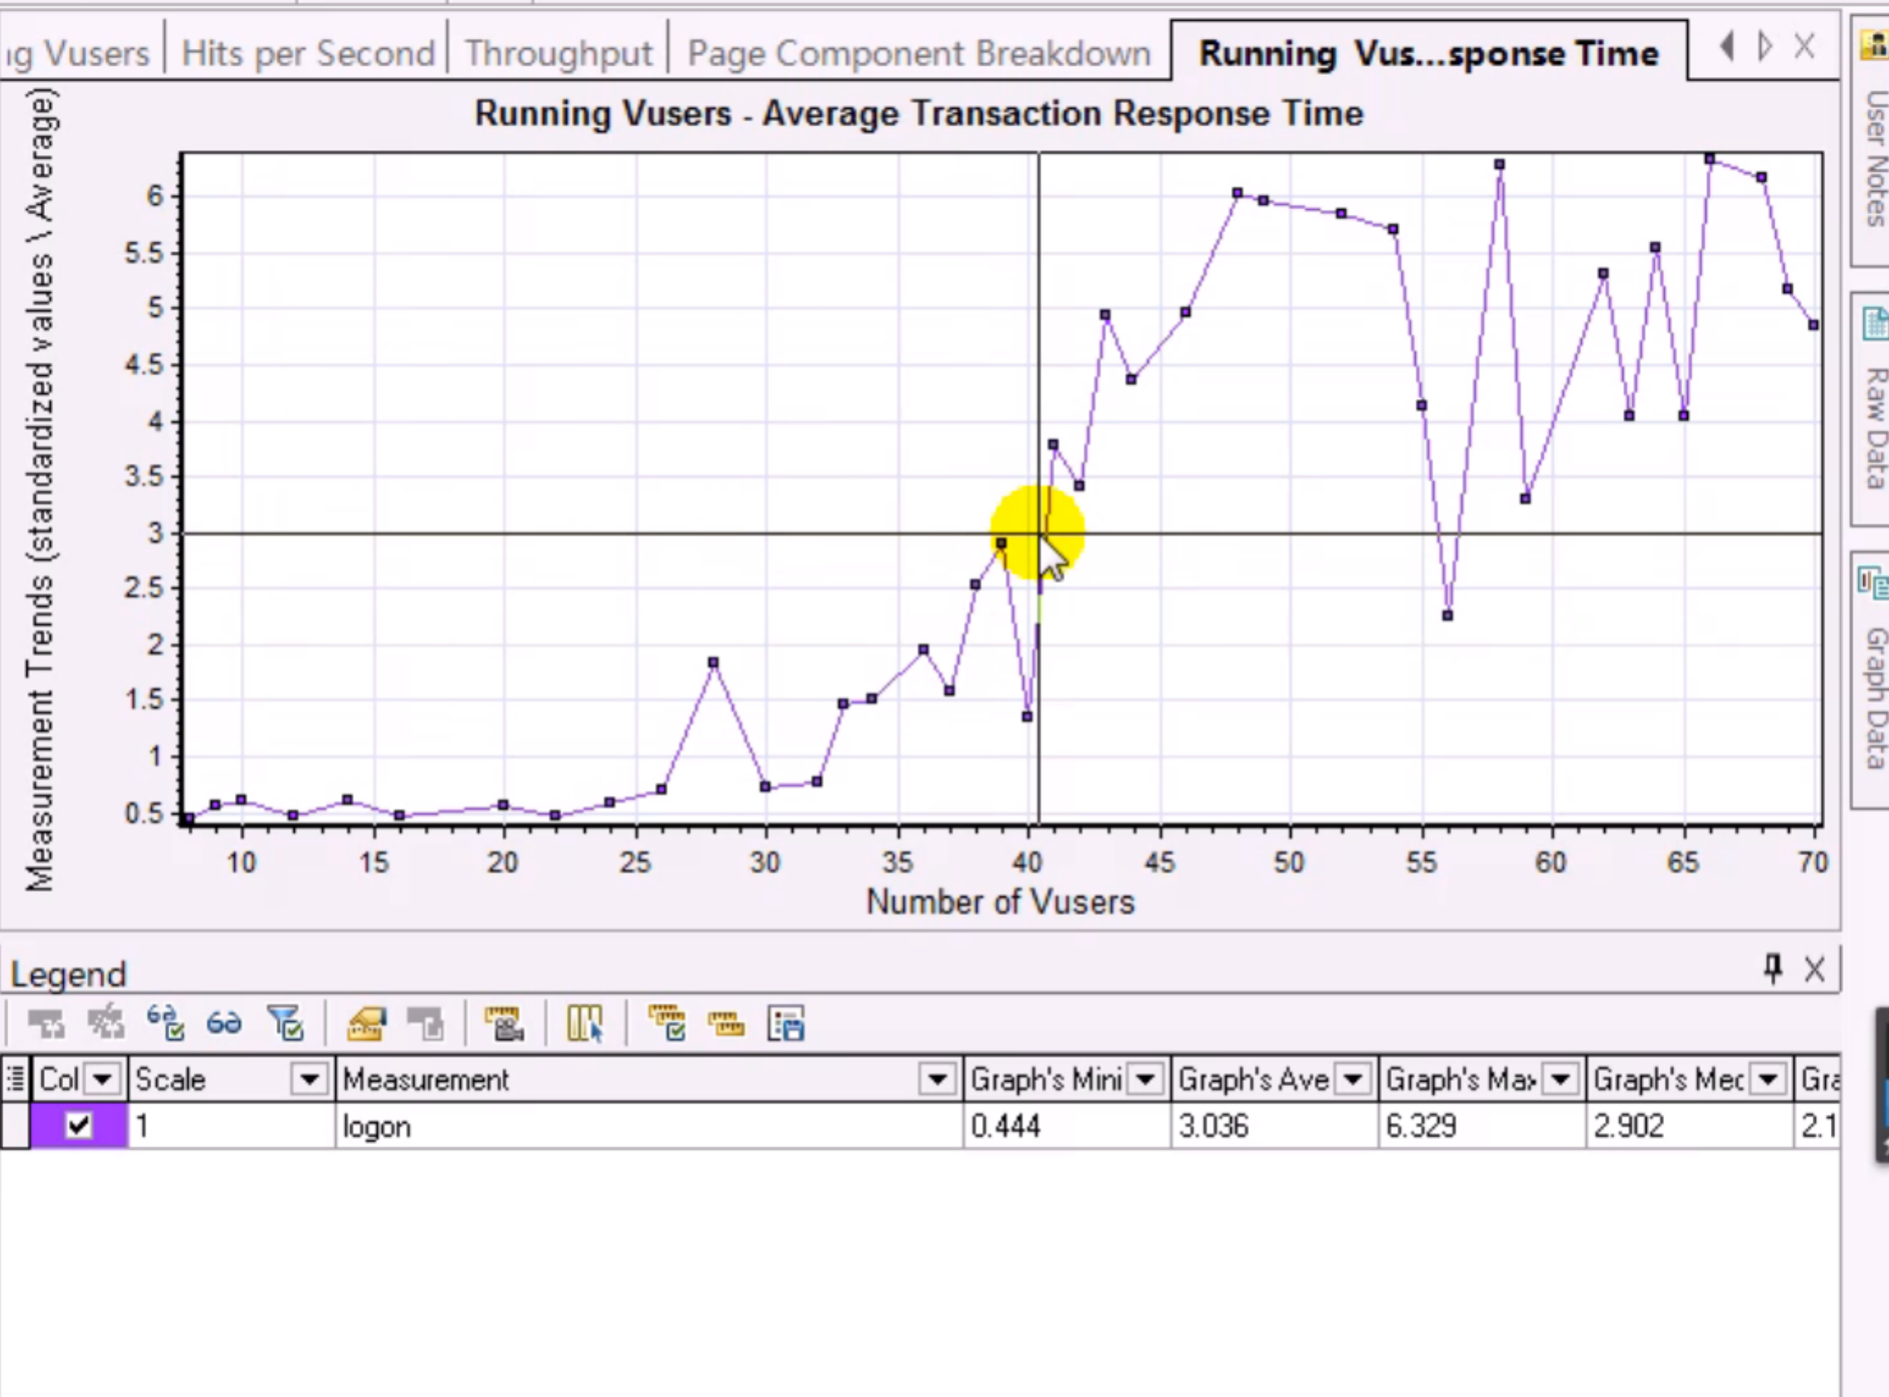

From this graph, the login’s response time of 3 seconds can handle 41 users. If the login function handles more than 45 concurrent users, the response time would be too long for users to wait.

3. Hits per Second Graph

The graph shows the HTTP requests sent to the server by Vusers every second. The line can show whether the system is stable. If the line goes down with time going, one possible reason is that the server is facing bottleneck problem.

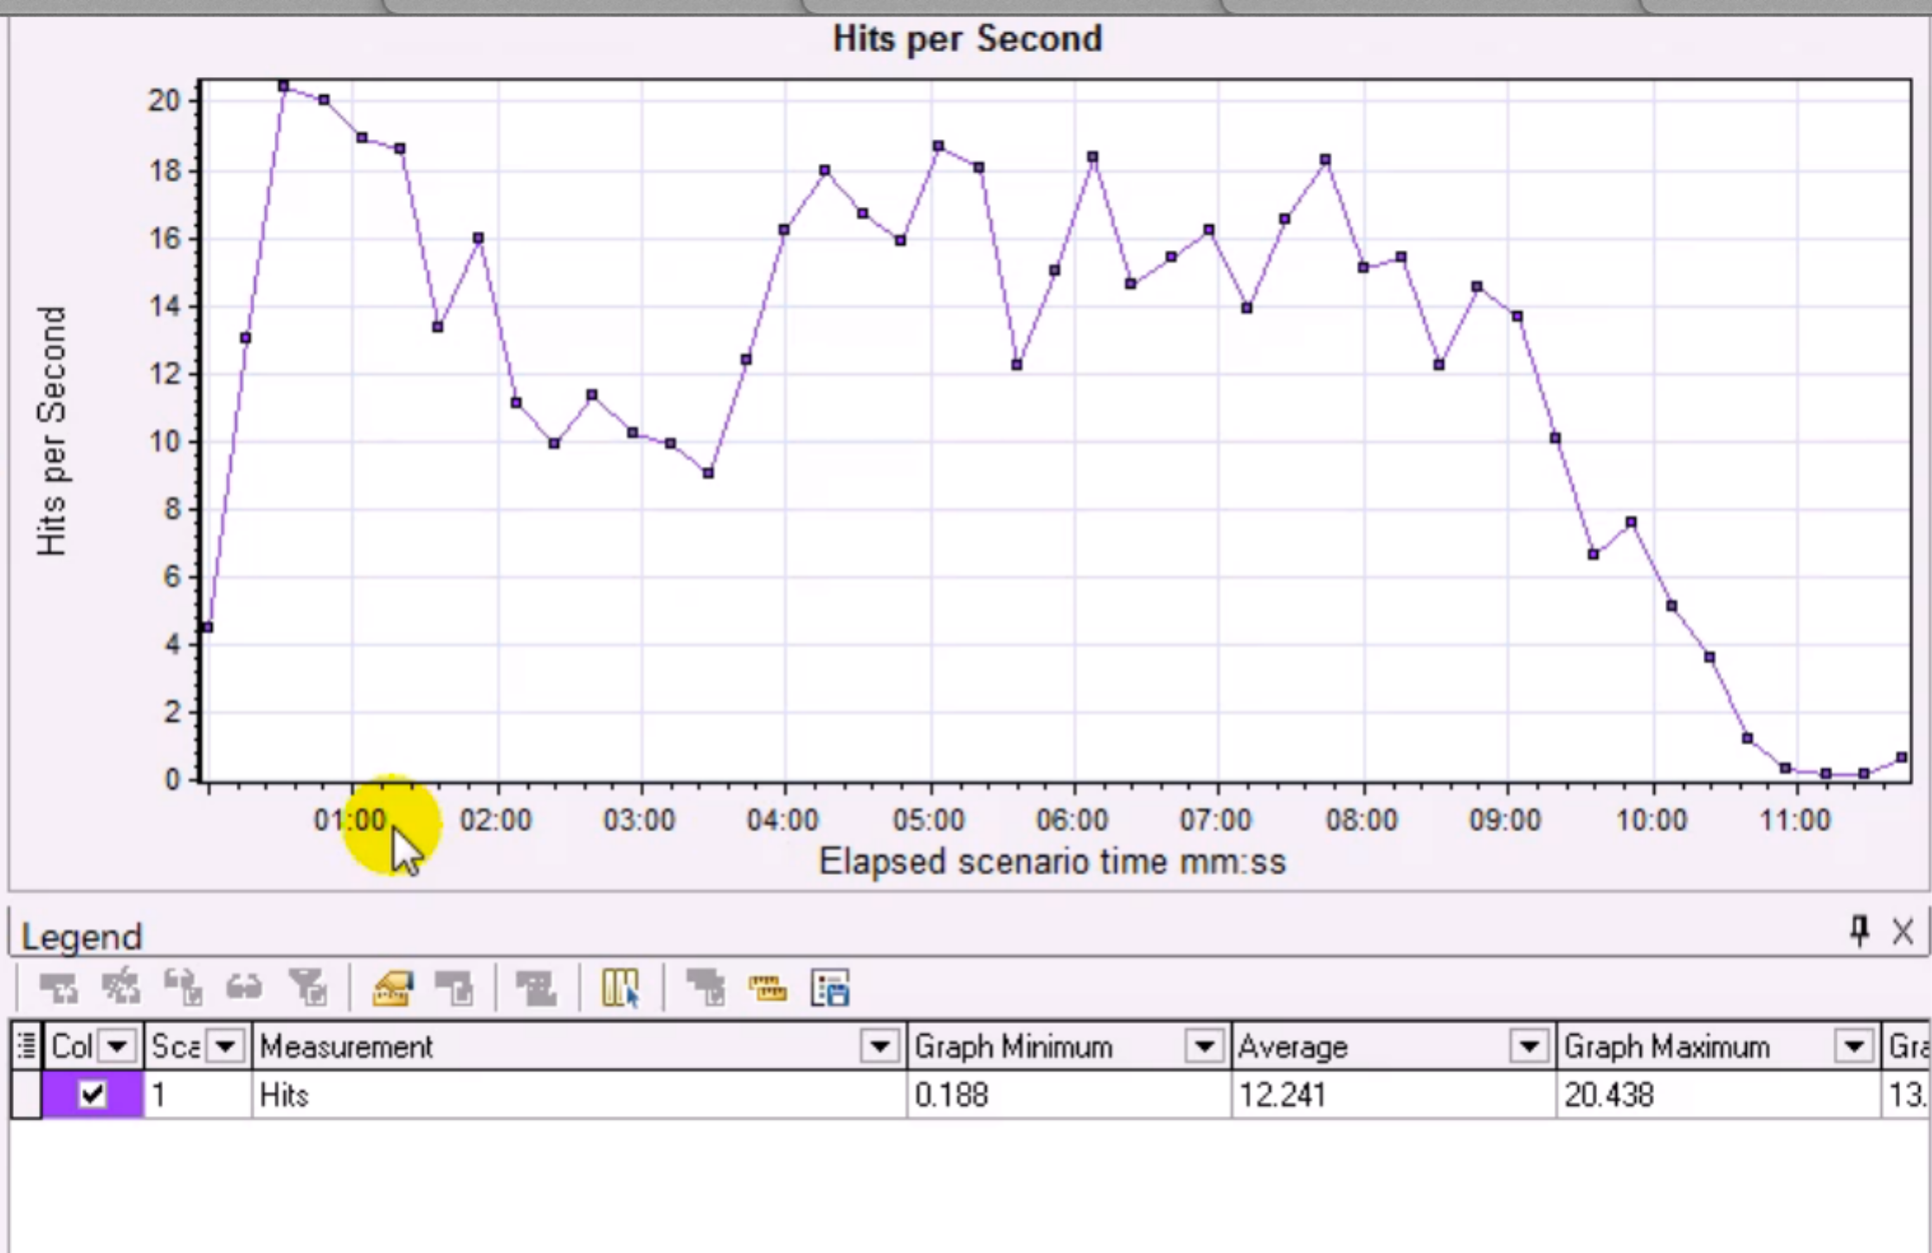

This graph can be merged with the number of running Vuser.

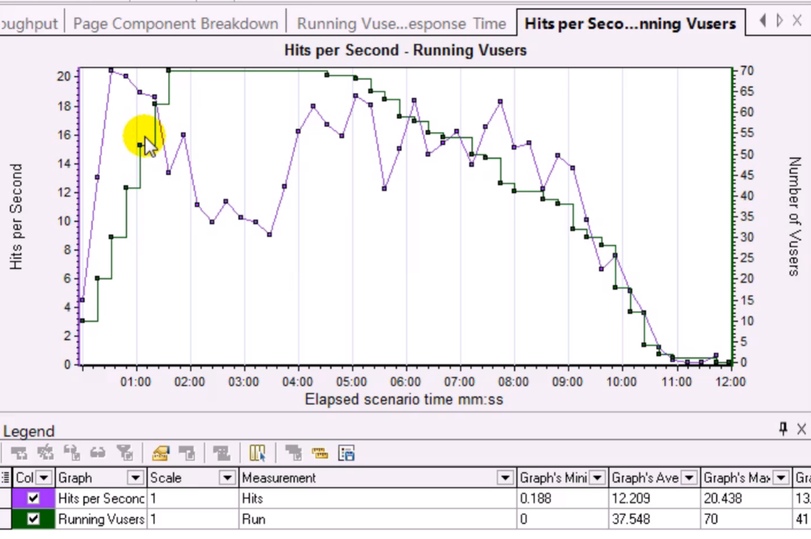

The server may face bottleneck when there is 70 Vusers.

4. Throughput Graph

The amount of data successfully sent by the client the server in one unit of time. Important index of the server performance.

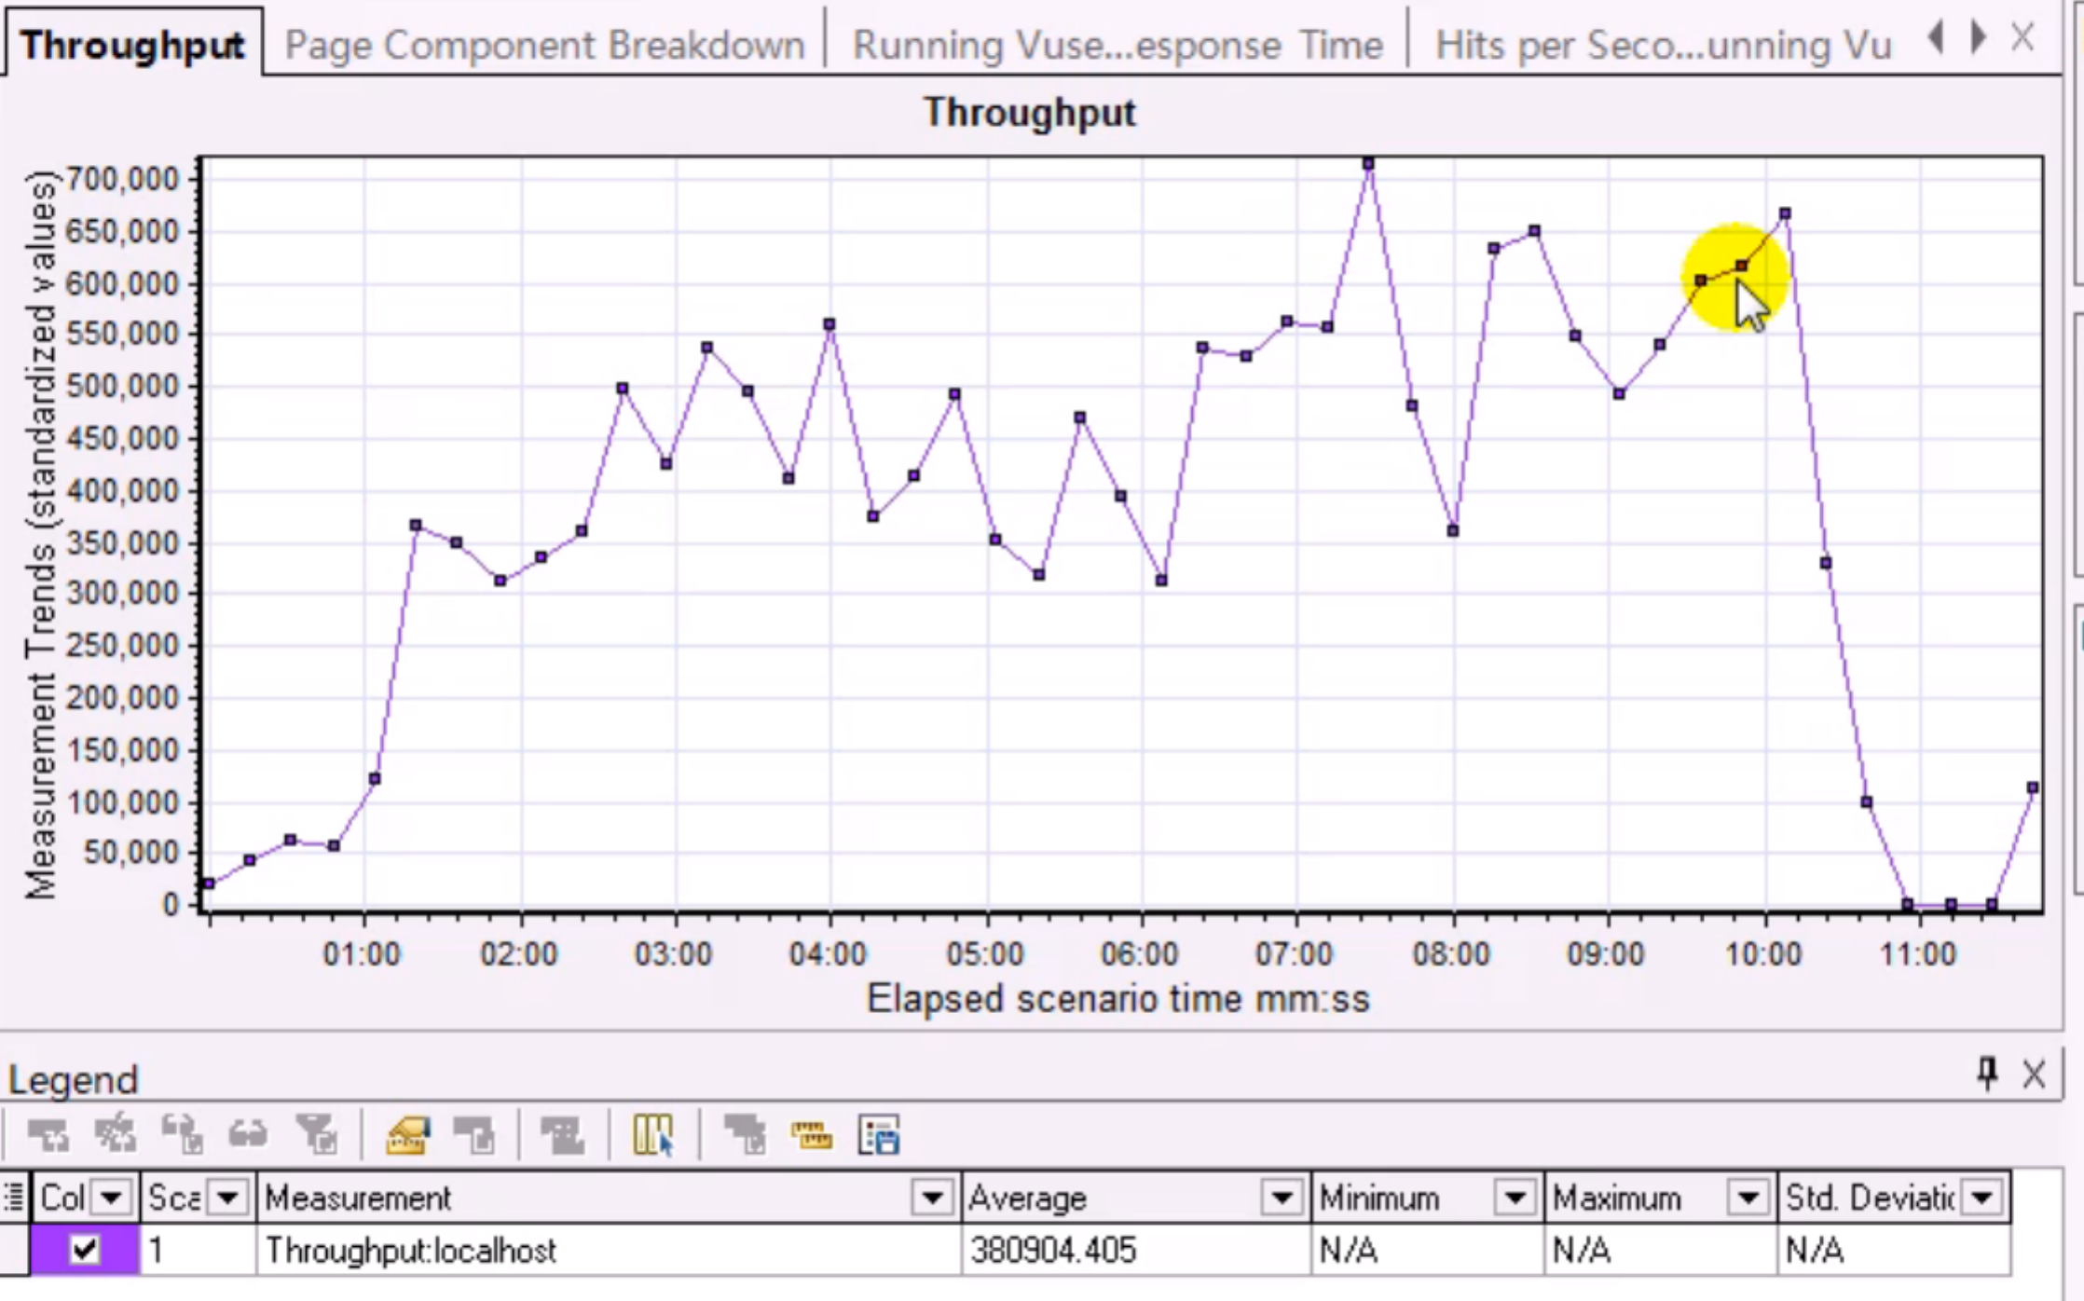

5. Vusers and Throughput Correlated Graph

In the normal situation, with the increasing of the Vusers’ amount, the throughput would increase. This graph can be used to find the bottleneck.

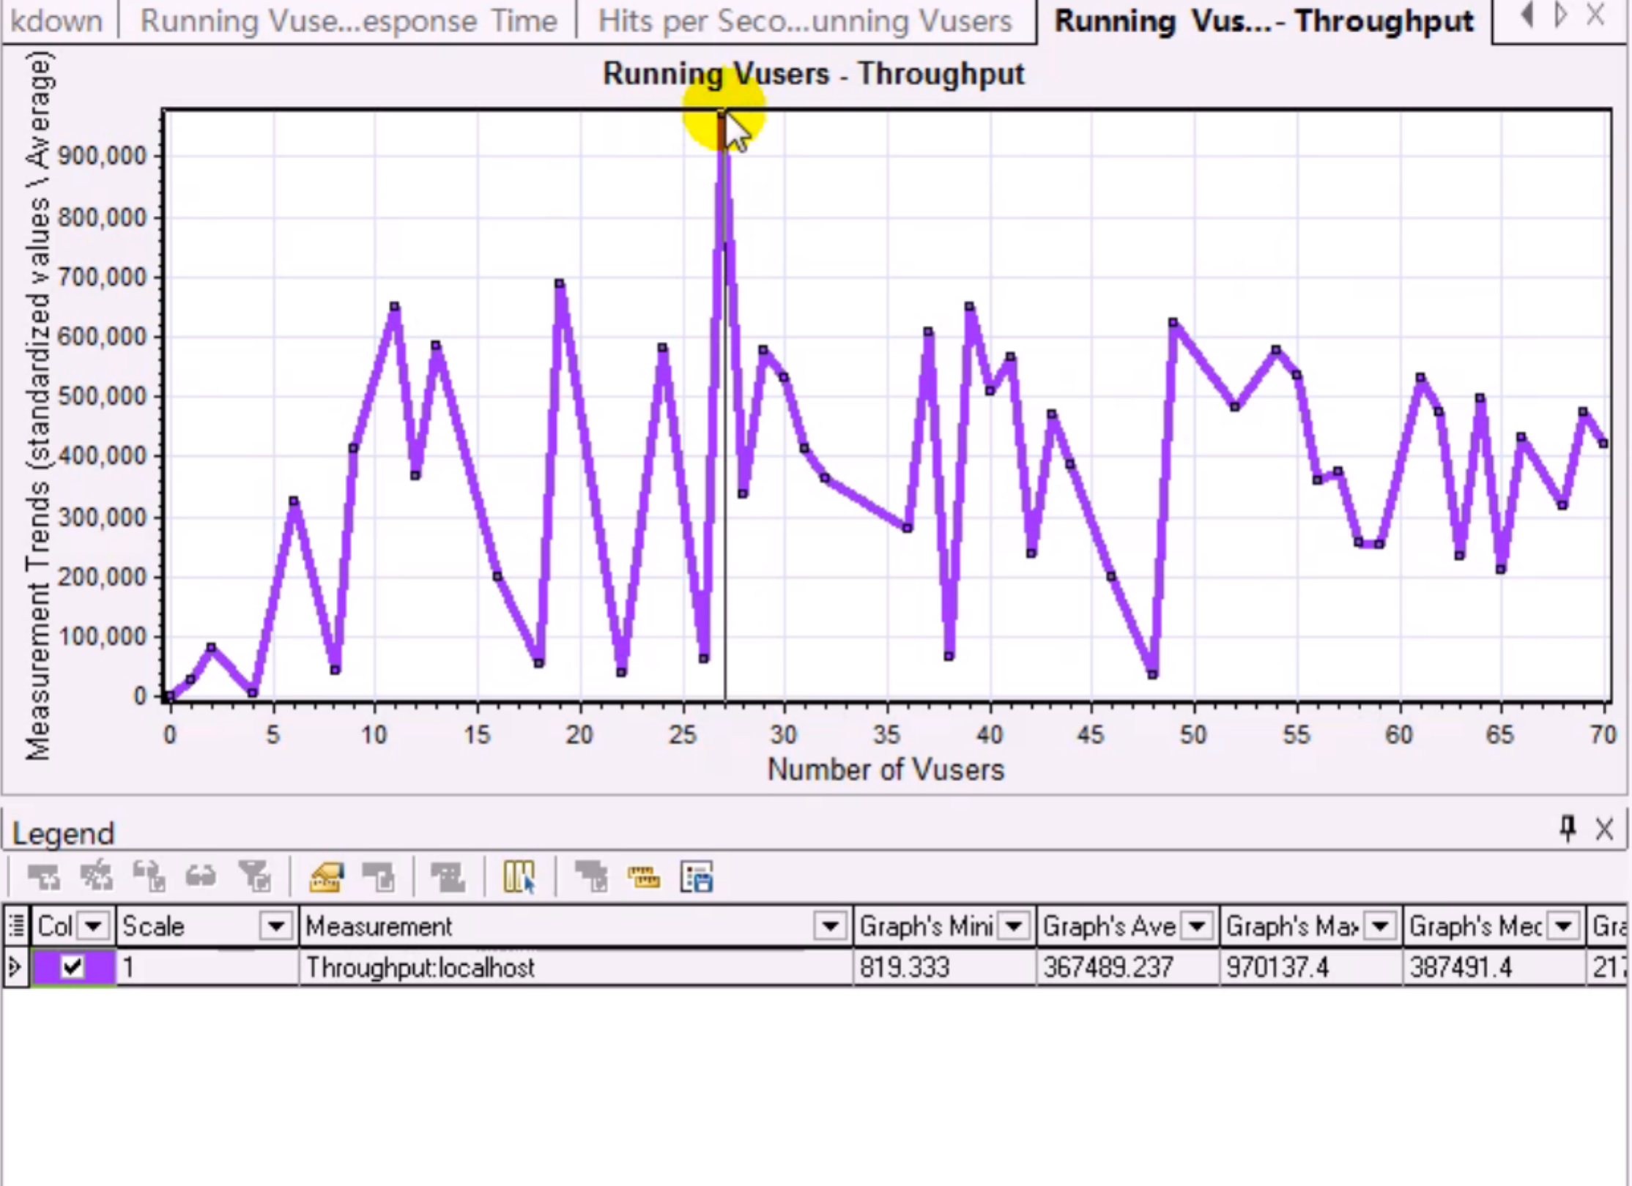

The maximum amount of users the system can handle may be 27.

6 Hits per Second and Throughput Correlated Graph

In normal situation, with the increasing of Hits per Second, the throughput would increase. If not, the server is facing bottleneck.

